Atomic Elements and Archeology Student Handout

Introduction: Archeology and XRF
Archeologists are scientists who study how humans lived in the past. They specifically use artifacts, or the objects made and used by past peoples, to learn more about their daily activities. Archeologists apply a wide variety of techniques to analyze artifacts, ranging from historical research to microscopic analysis.
X-ray fluorescence (XRF) is one common scientific tool archeologists use to study artifacts. Using x-ray energy, this method identifies which elements an artifact is made of and the quantities of each element, essentially creating an atomic “fingerprint” for the object. Archeologists can then match this fingerprint to natural material sources within the landscape, such as clay beds and rock outcrops, to locate where past peoples acquired the material they used to create the artifact.
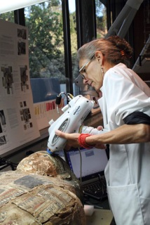
A researcher using a pXRF (portable XRF) spectrometer. Penn Museum.

How XRF Works
XRF relies on the fact that all objects on Earth are composed of a certain combination of elements. An element is defined by the specific number of protons, neutrons, and electrons within its atoms. Protons and neutrons are contained in the atom’s nucleus. Just like moons around a planet, electrons orbit the nucleus in different energy levels. It is helpful to think of these energy level like steps on a staircase. Each “step” is defined by the fixed amount of energy the electrons within the step contain. The step closest to the nucleus contain the lowest amount of energy, and can also hold the fewest number of electrons.
Depiction of carbon atom based on the Bohr model. National Park Service.

The distance between steps, i.e. the difference of energy between levels, is unique to each atomic element. To move up or down a step, electrons either gain or lose energy that is exactly equal to this fixed value. Electron movement causes atomic instability. To restore equilibrium, electrons in higher levels release their gained energy, often in the form of light or heat, and drop back down to fill electron “gaps” in the lower energy levels. Electrons fill the lowest energy level around the nucleus first.
XRF uses these principles of electron movement to identify elements within an artifact. To obtain readings, researchers hold an XRF spectrometer up to an object. The spectrometer emits x-ray energy that excites the atoms within the object and causes them to release electrons from their lower energy levels. Electrons in higher levels then release energy and drop down to fill the gaps. The amount of energy they release directly corresponds with the unique difference of values between levels. The spectrometer captures this radiated energy, termed fluorescence, to identify the elements within the sample object.
Graph of an obsidian artifact elemental "fingerprint." (Godfrey, D.I. and N. Haywood. Obsidian Sources in Ontario Prehistory. Ontario Archaeology 41:29-35. 1984.)
Spectrometers analyze the quantity of each element within the artifact by counting how many “hits” of a certain energy amount are received. As seen in the graph above, the energy level determines the type of element while the number of counts illustrates its intensity. The object studied here has an elemental “fingerprint” primarily composed of iron (Fe), rubidium (Rb), and zirconium (Zr).
The next step is to match an artifact’s fingerprint to material sources on the landscape. Archeologists take many samples from a specific source to know the possible range of element ratios present there. If an artifact’s fingerprint falls within a given range, it is likely that the object was made from that source material.
Elemental compositions and sources of obsidian artifacts from Yellowstone National Park. Hughes, Richard E. Geochemical Research Laboratory Letter Report 2017-91, 2.

Case Study: Using XRF at Yellowstone National Park
Replicas of obsidian points and knife (top left) found at Yellowstone National Park. National Park Service.
For thousands of years, people utilized stone (or lithic) tools for everyday tasks. The tools shown here are made of obsidian. Obsidian is a very hard and sharp volcanic glass, which makes it an ideal material for making stone tools such as knives, spearpoints, and arrowheads. Pieces often look similar to the human eye, yet their microscopic properties can vary greatly. Obsidian sources are special in that they form during one geologic event, such as a volcanic eruption, rather than slowly over hundreds or thousands of years. All obsidian created during that event will therefore contain a similar range of atomic elements. This elemental fingerprint, discoverable through XRF, will differ between sources.

Archeologists working at Yellowstone National Park used XRF to discover how past peoples used obsidian sources over at least the past 11,000 years. Yellowstone contains many natural sources of obsidian that are scattered throughout the landscape. By mapping obsidian sources and where tools created from specific material are found at archeological sites across the landscape, archeologists are able to hypothesize how individuals obtained the material they needed. Their findings demonstrated that people within the past often walked for miles across the land or along the various rivers to obtain the required stone. Obsidian collection may also have occurred while individuals were traveling through the area on hunting expeditions or occupying a nearby seasonal settlement.
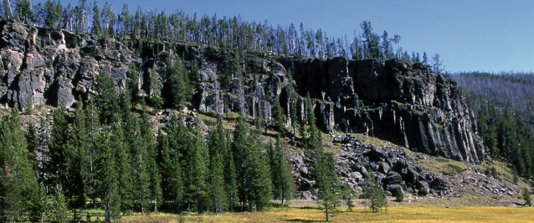
Obsidian Cliff, Yellowstone National Park. National Park Service.
Archeologists found that past peoples in the Yellowstone area were commonly relying on Obsidian Cliff material. Due to its cultural and scientific significance, Obsidian Cliff was designated as a National Historical Landmark in 1996. To provide for the protection of cultural resources associated with Obsidian Cliff National Historic Landmark, the site is closed to recreational use. Visitors can view Obsidian Cliff from a vehicle pull-out, walking path, and viewing platform.
By using these maps of material sources and where tools were found, archeologists can start recreating ancient trade routes. For instance, tools made from Obsidian Cliff material were excavated on archeological sites as far away as Texas and Alberta, a Canadian province. To cross those distances, it is possible that tools were passed between many “middlemen” traders. Therefore, XRF data can help understand not only how past peoples interacted with their landscape but also with one another.
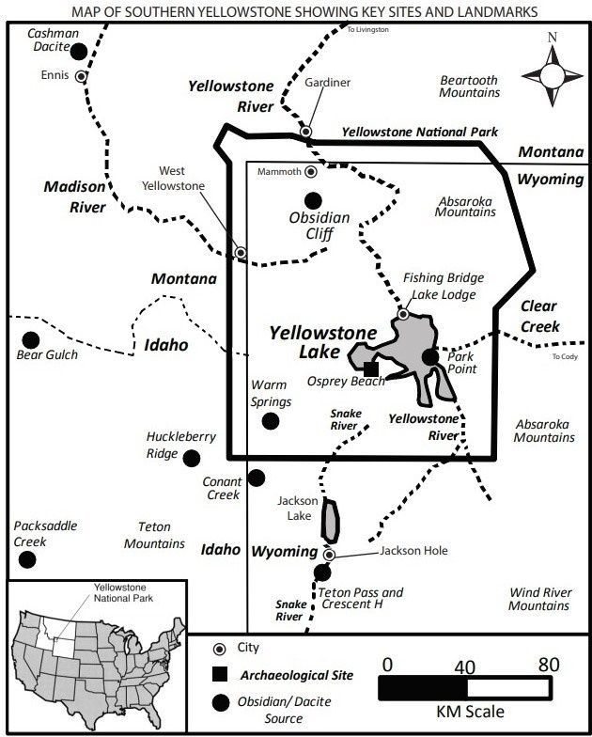
Map of Yellowstone obsidian sources. Adapted from Yellowstone Archaeology: Northern Yellowstone. Douglas H. Macdonald and Elaine S. Hale, editors. University of Montana Department of Anthropology contributions to Anthropology 13(2), 2013.

Park, Robin J. M. “Obsidian, Culture, and Convenience: New Perspectives from Yellowstone.” In Yellowstone Archaeology: Northern Yellowstone. Douglas H. Macdonald and Elaine S. Hale, editors. University of Montana Department of Anthropology contributions to Anthropology 13 (1), 119.

